**CS/SE 6360.004/005 - Assignment 3**

**Due Date:** October 19, 2015, 11:59 PM

1. Draw an ER diagram for university library system. Specify key attributes of each entity type and structural constraints on each relationship type (cardinality ratios and participation constraints). State any assumptions you make.

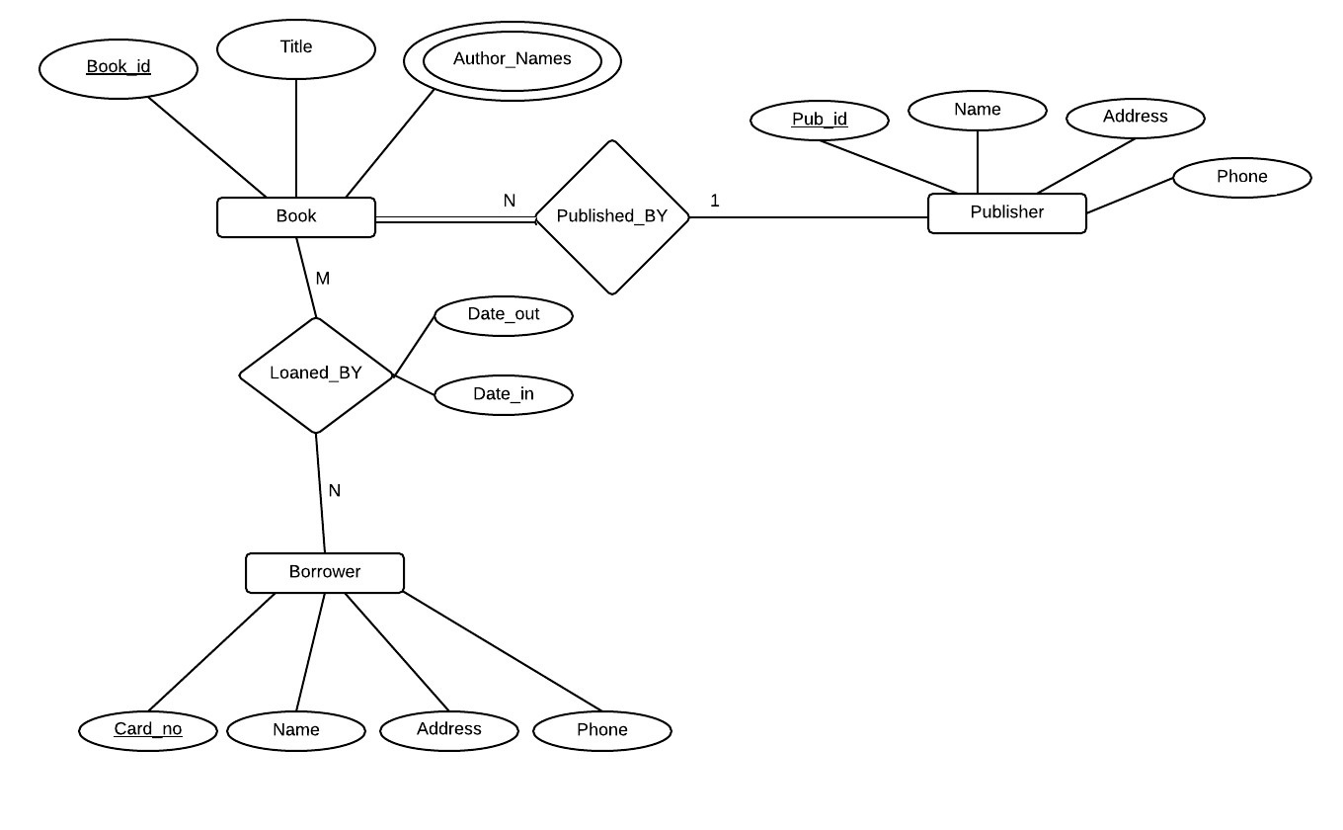

**Assumptions:**

a) Each book has a unique book_id, even if they are copies of the same book.

b) Books can have multiple authors but only 1 publisher.

c) A publisher is identified by pub_id and it can publish as many number of books.

d) All books published by a publication can be removed from the book table but the publisher name should need not be removed. i.e, this allows the publisher in the publisher table to even have no books published.

e) A borrower can borrow any number of books or need not borrow any also.

f) Each book borrowed should have date_out and date_in recorded with it.

**2.** Following is the data requirements for an art museum:

* The museum has a collection of ART_OBJECTS . Each art object has a unique IDNo, and Artist, if known, a Year (when created, if known) a Title and a Description. The art objects are categorized in several ways, as discussed below.
* ART_OBJECTS are categorized based on types. There are three main types, Painting, Sculpture and Statue, plus an ‘Other’ category for those that don’t fit into one of the main types.
* A PAINTING has a PaintType (oil, watercolor, etc) a material on which it is CrawnOn (paper, canvas, wood) and Style (modern, abstract etc)
* A SCULPTURE or a STATUE has a Material from which it was created (wood, stone, etc) Height, Weight and Style.
* An art object in the OTHER category has a Type(print, photo, etc) and Style.
* ART_OBJECTS are also categorized as PERMANENT_COLLECTION, which are owned by the museum (DateAcquired, whether it is OnDisplay or Stored and Cost) or BORROWED, which has information on the Collection (where it was borrowed from), DateBorrowed, and DateReturned.
* ART_OBJECTS also have information describing their country-culture using information on country/culture of Origin (Italian, Egyptian, American, Indian etc) and Period(Renaissance, Modern, Ancient)
* The museum keeps track of ARTISTS’s information, if known: Name, DateBorn, DateDied, CountryOfOrigin, Period, MainStyle and Description. The name is assumed unique.
* Different EXHIBITIONS occur, each having a Name, StartDate and EndDate. EXHIBITIONS are related to all the art objects that were on display during the exhibition.
* Information is kept on other COLLECTIONS with which the museum interacts, including Name (unique), Type (museum, personnel etc), Description, Address, Phone and ContactPerson.

1. Draw an EER diagram for this application. Discuss any assumptions you make.

Assumptions:

1. Same artist could have created many ART_OBJECTS .
2. Each ART_OBJECTS can be displayed in only one exhibition at a time, but there is a seaparate attribute for the start and start date. So also after the exhibition ends these records are still maintained in the table exhibitions.
3. An exhibition includes many ART_OBJECTS.

**EER is uploaded in a separate file. PLEASE REFER THE 2_ANS.JPEG UPLOADED**

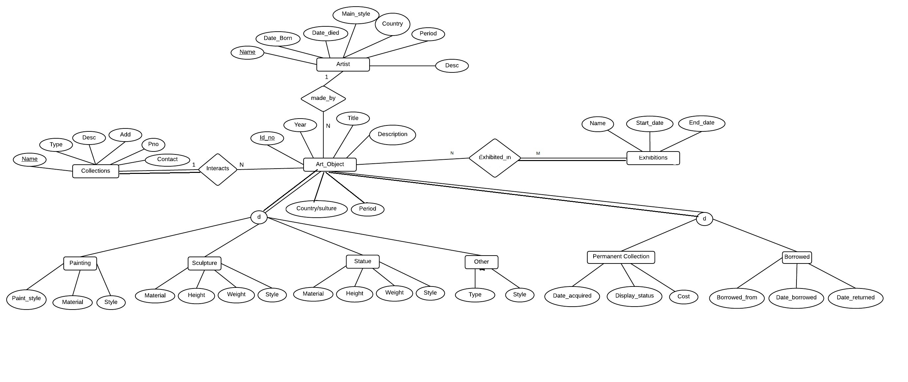



**b.** Map the designed EER diagram to relational schema.

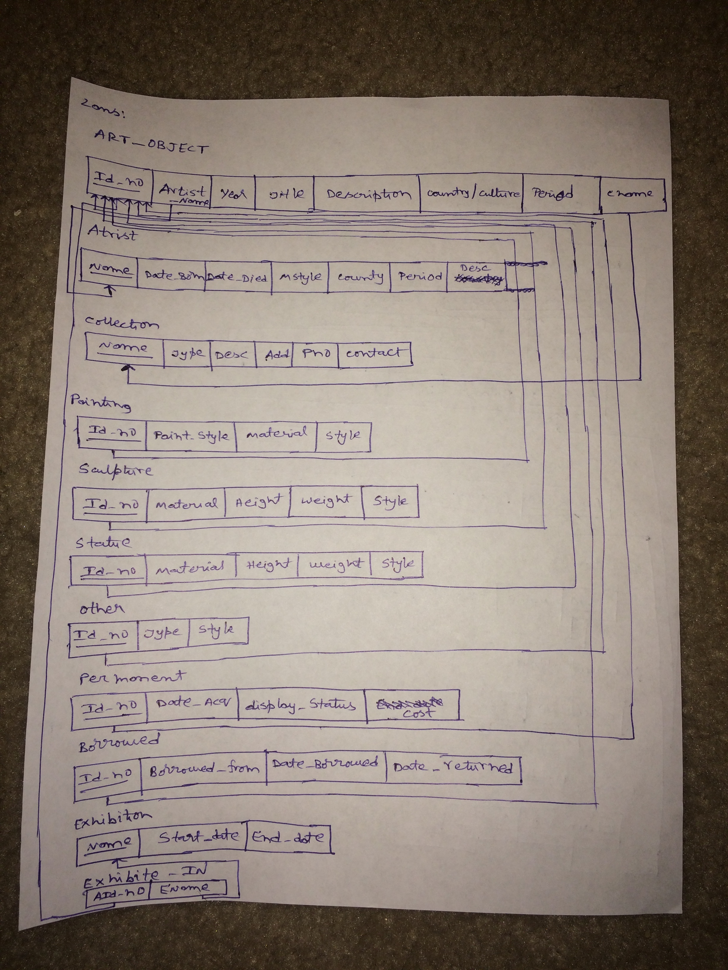

**3.** Consider the ER diagram in following figure. Map the given conceptual schema to relational database schema.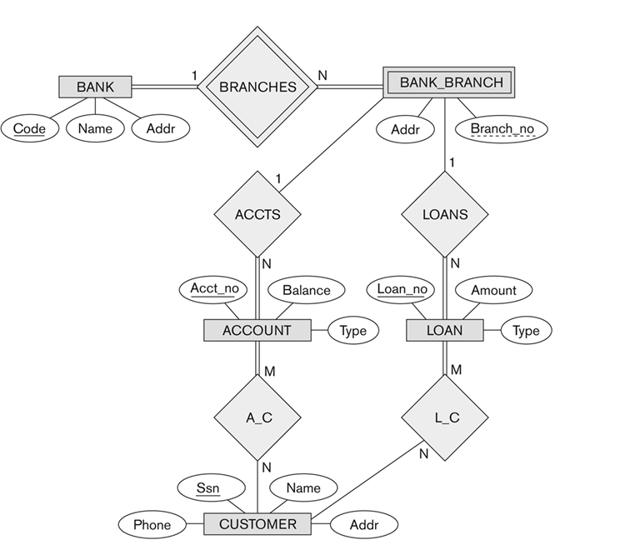

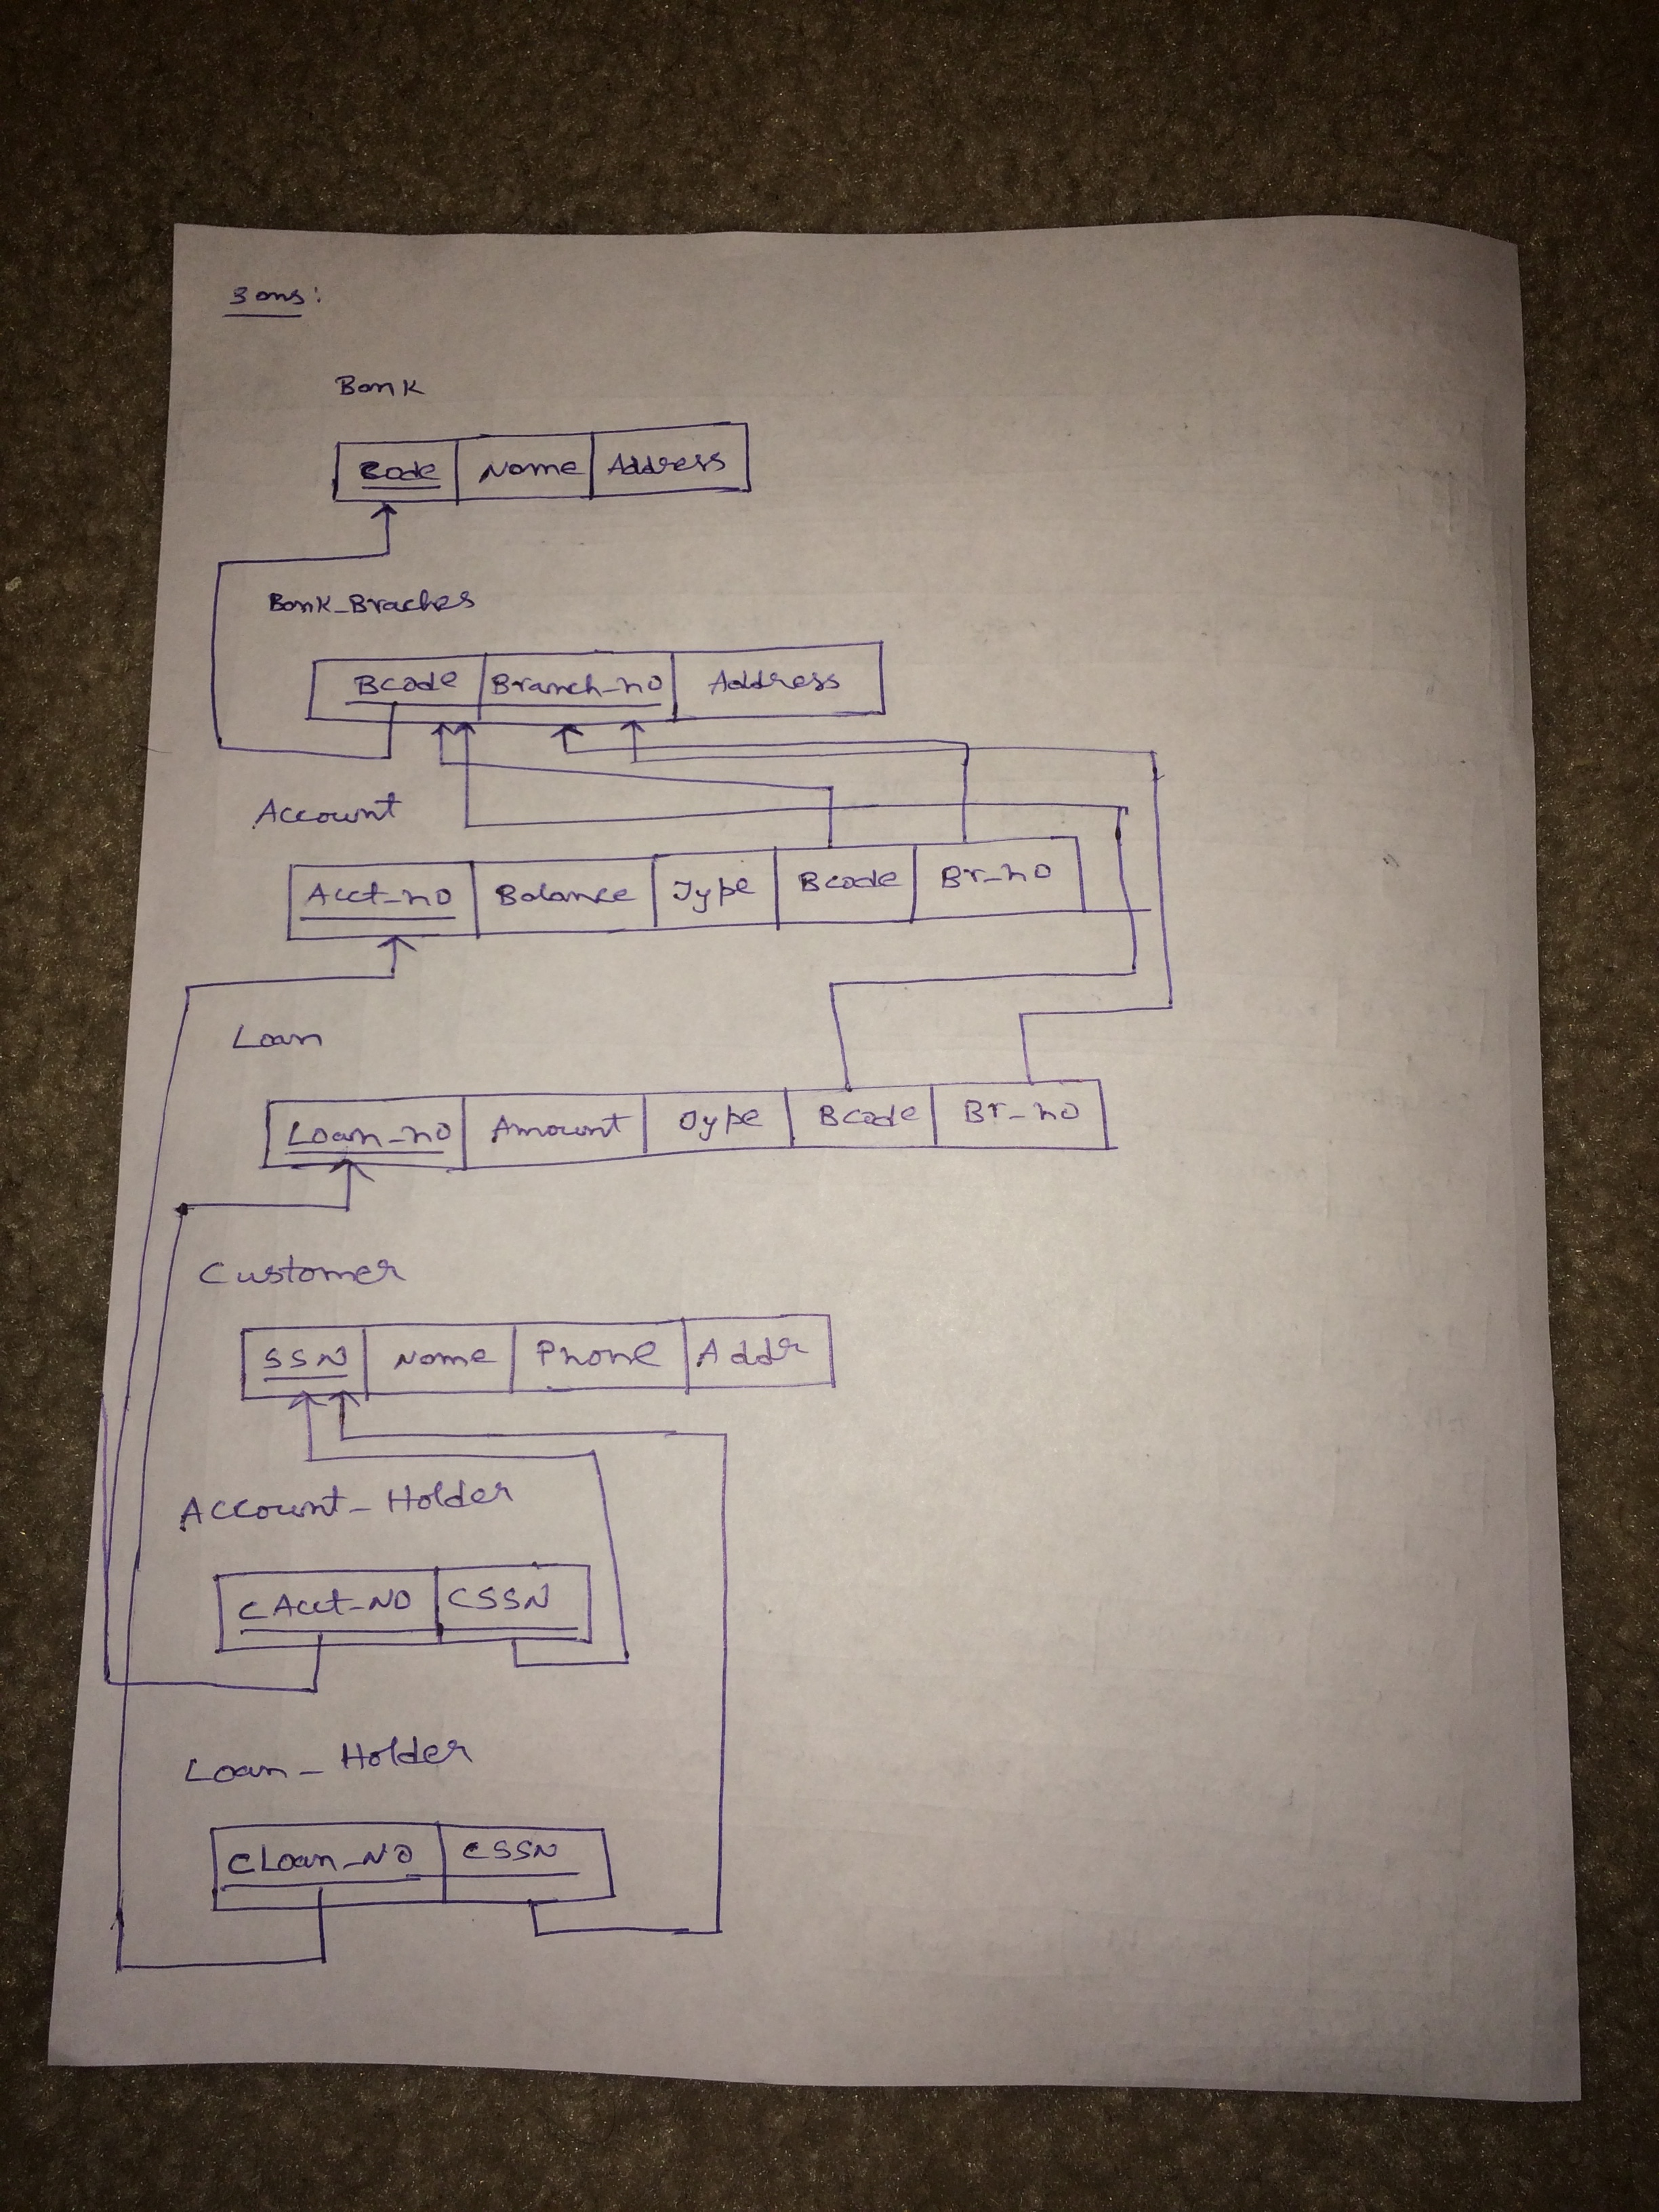

**4.** Consider the EER diagram in below figure for a car dealer. Map the EER schema into a set of relations. For the VEHICLE to CAR/TRUCK/SUV generalization, consider the four options (8A, 8B, 8C, 8D) and show the relational schema design under all options.

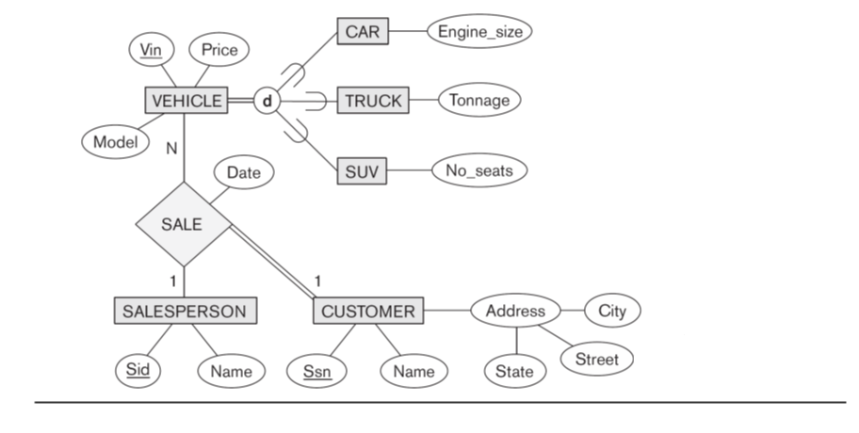

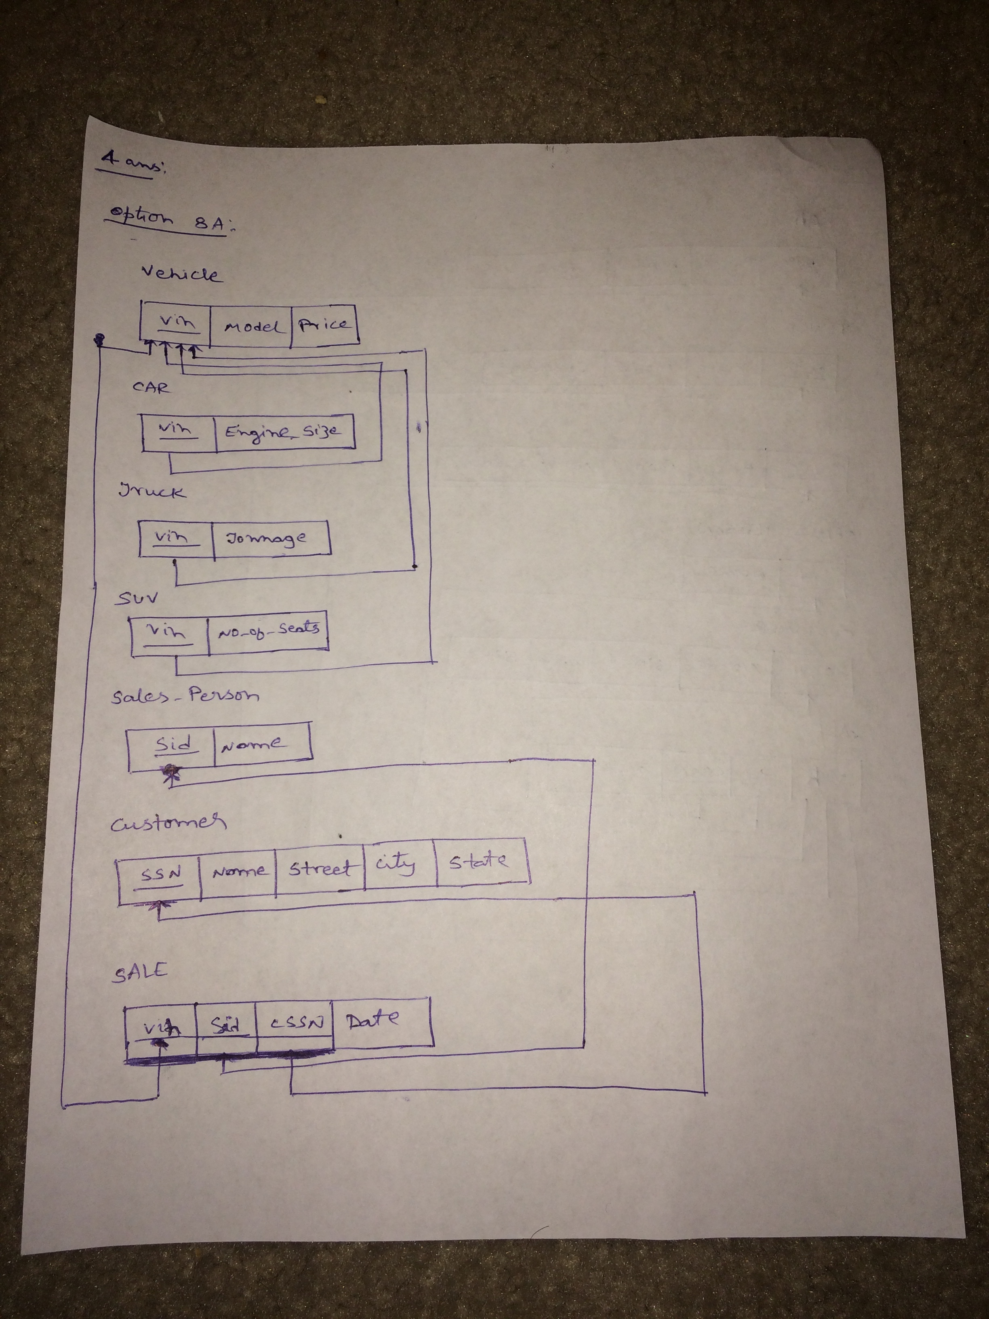

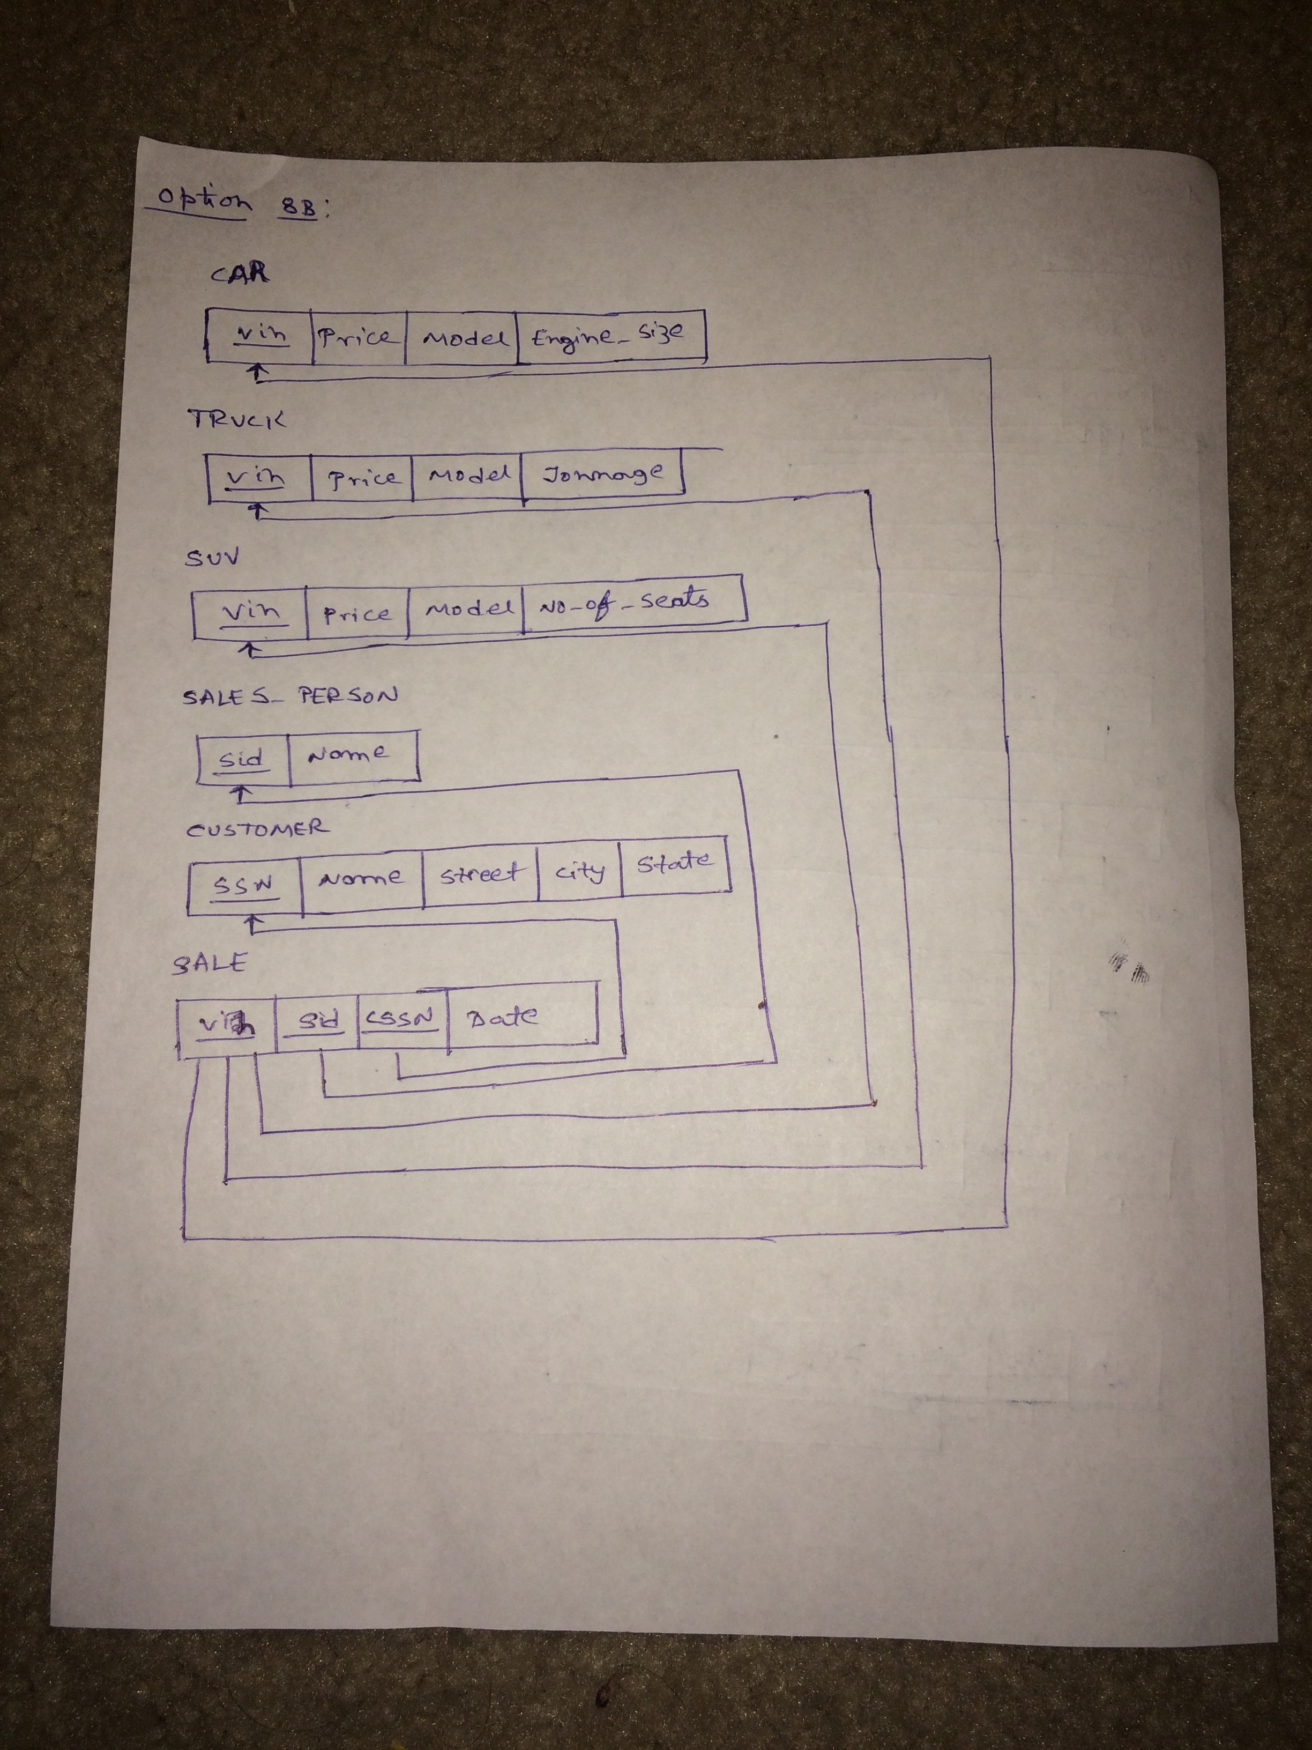

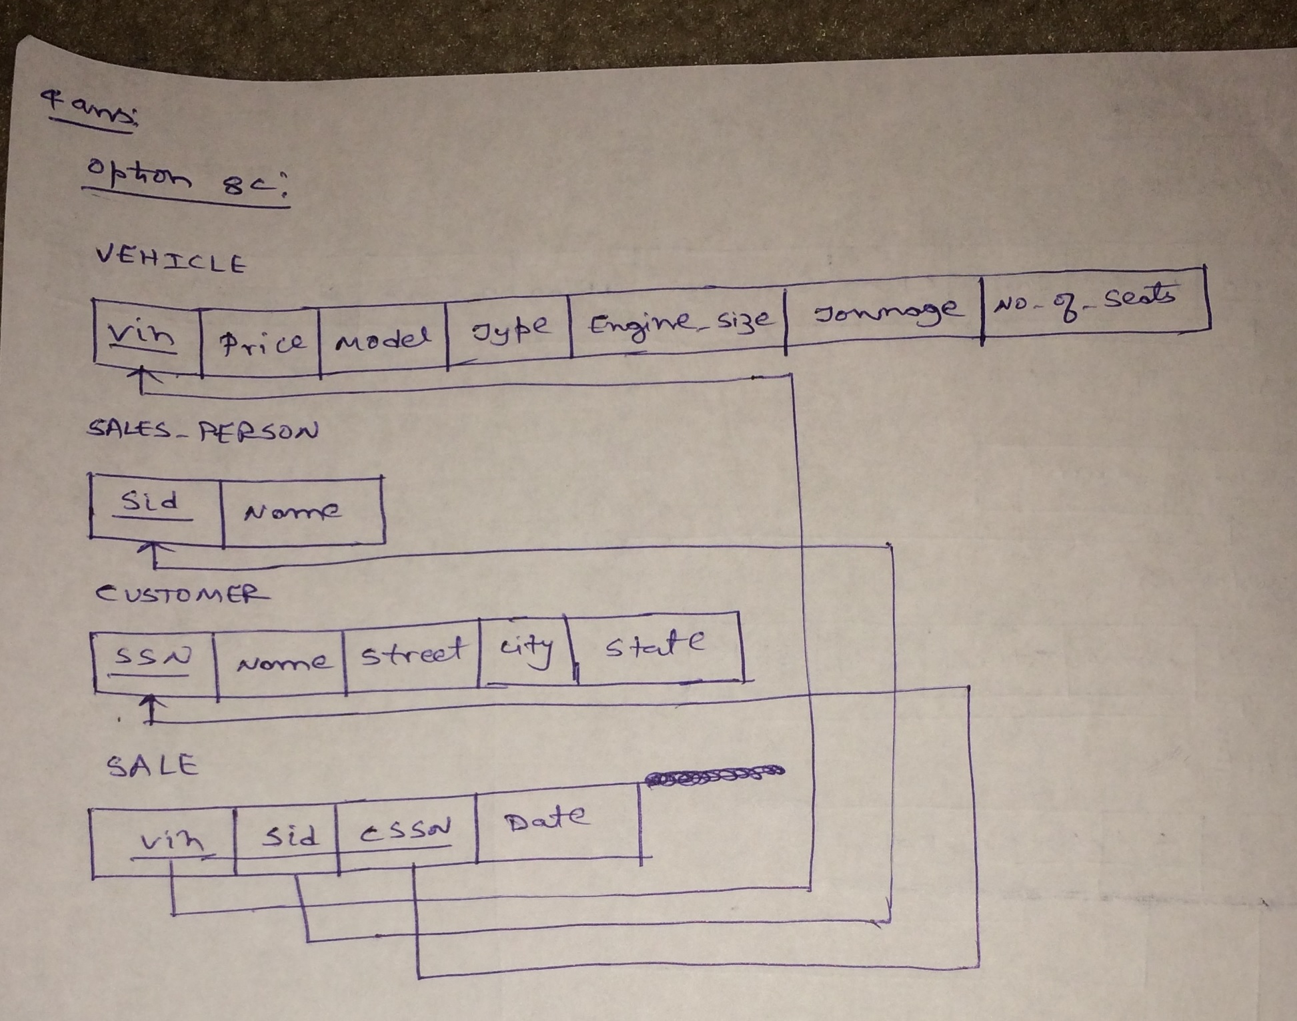

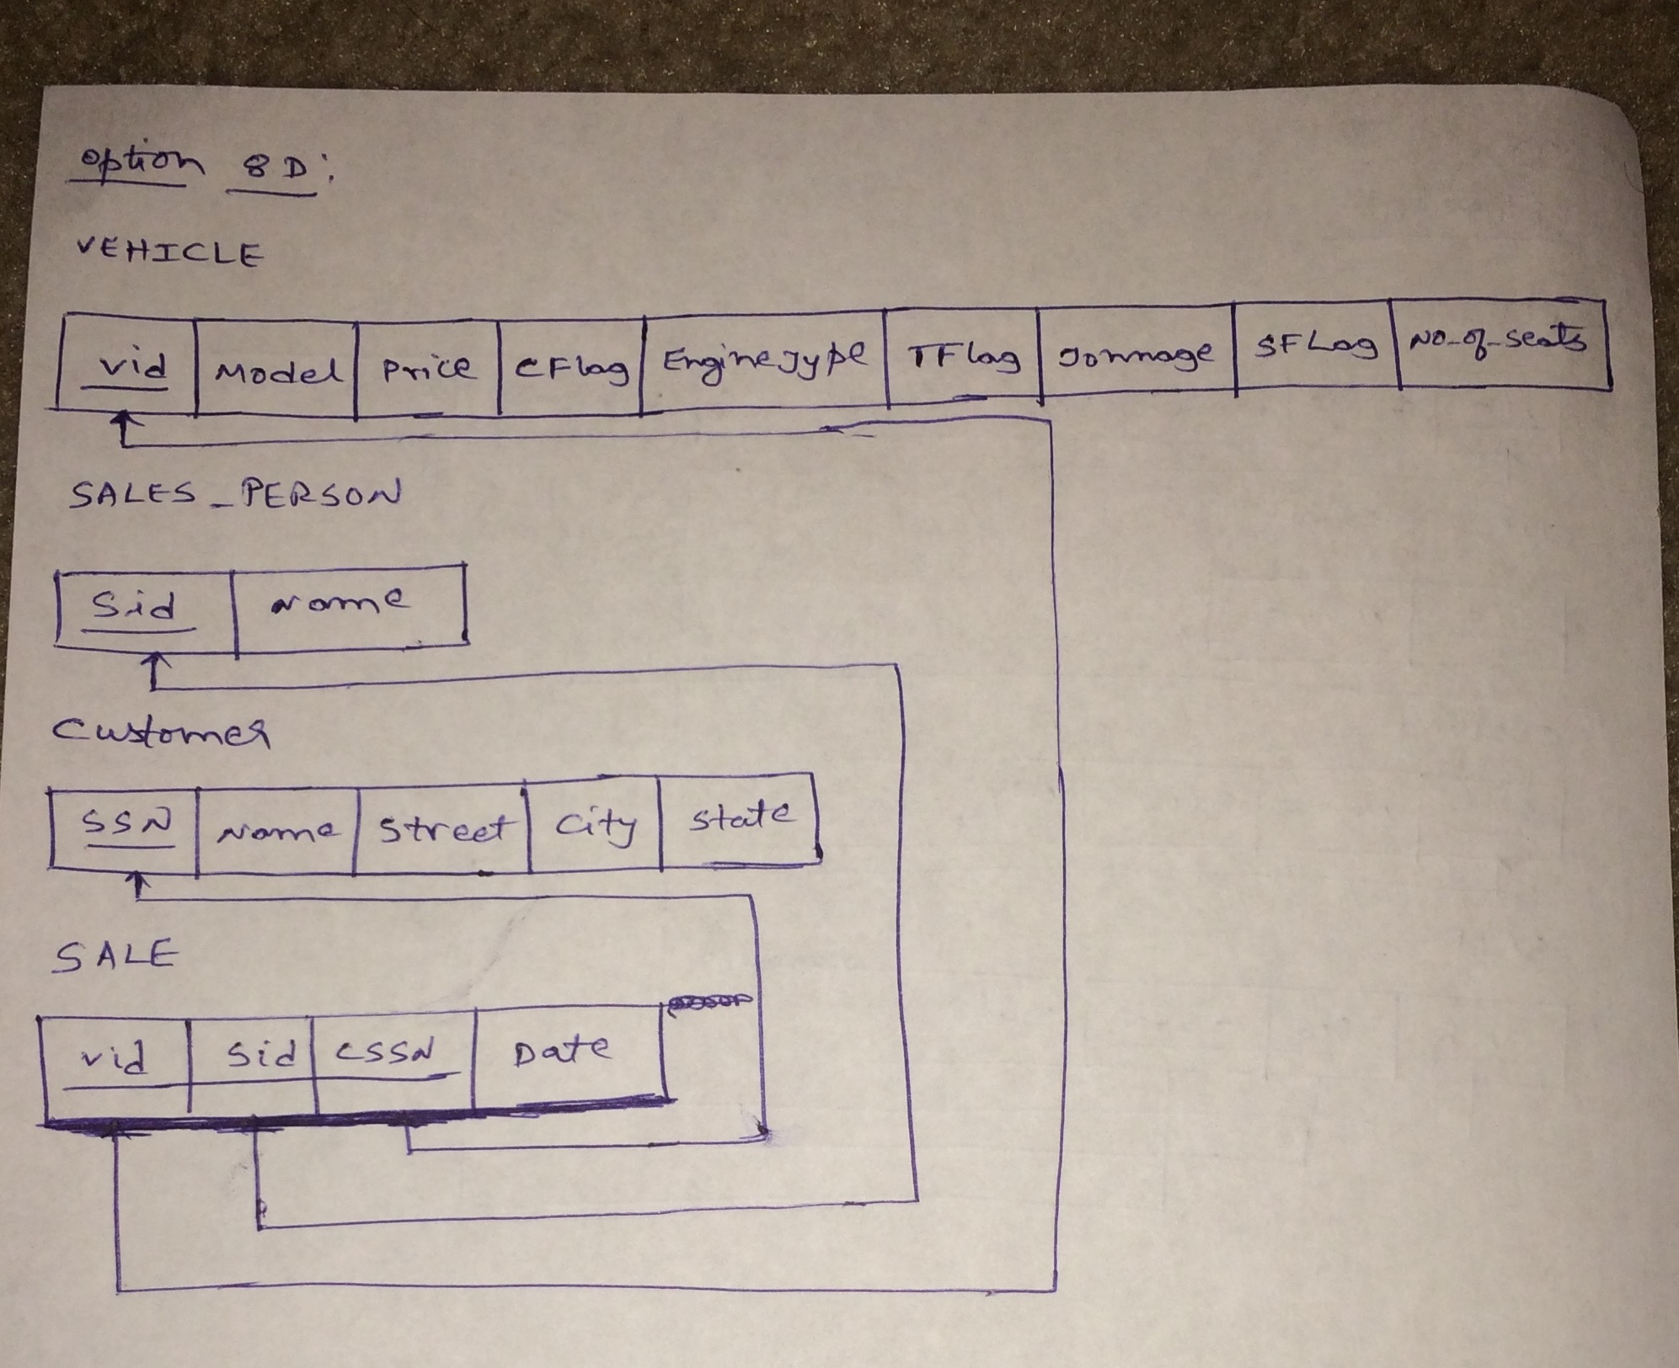

**NOTES:**

* ER diagrams should be drawn electronically. You can use one of chart drawing tools (i.e. ERwin or lucidchart.com) to simplify drawing charts.
* You can use different notations to show cardinality ratios. (i.e. Crow’s Foot notation)

**Each item (1, 2a, 2b, 3, 4) is 20 points.**